# **Lab 11**

# **Google Lighthouse Extension Documentation**

## **What is Lighthouse?**

**Lighthouse** is an open-source tool developed by Google to audit web pages for performance, accessibility, SEO, best practices, and Progressive Web App (PWA) compatibility. It helps developers improve the quality of their websites.

Lighthouse can be accessed:

* As a **Chrome DevTools tab** (built-in)
* As a **Chrome extension**
* From the command line (lighthouse)
* In **PageSpeed Insights**

## **Why Use Lighthouse?**

Lighthouse is commonly used to:

* Evaluate page **performance** (loading speed, render times)
* Improve **accessibility** (for users with disabilities)
* Follow **SEO best practices**
* Detect **common coding issues**
* Ensure PWA compliance (if applicable)

## **How to Use Lighthouse in Chrome Inspect Element**

### **Step-by-step Guide**

### **1. Open Your Website in Chrome**

Go to the webpage you want to audit.

**📸 Insert Screenshot of your site opened in Chrome**

### **2. Open Chrome DevTools**

* Right-click anywhere on the page → click **Inspect**,  
   OR
* Press Ctrl + Shift + I (Windows) or Cmd + Option + I (Mac)

### **3. Configure Lighthouse Audit**

* Choose device type: **Mobile** or **Desktop**
* Select categories: Performance, Accessibility, Best Practices, SEO, PWA
* Click **Analyze page load**

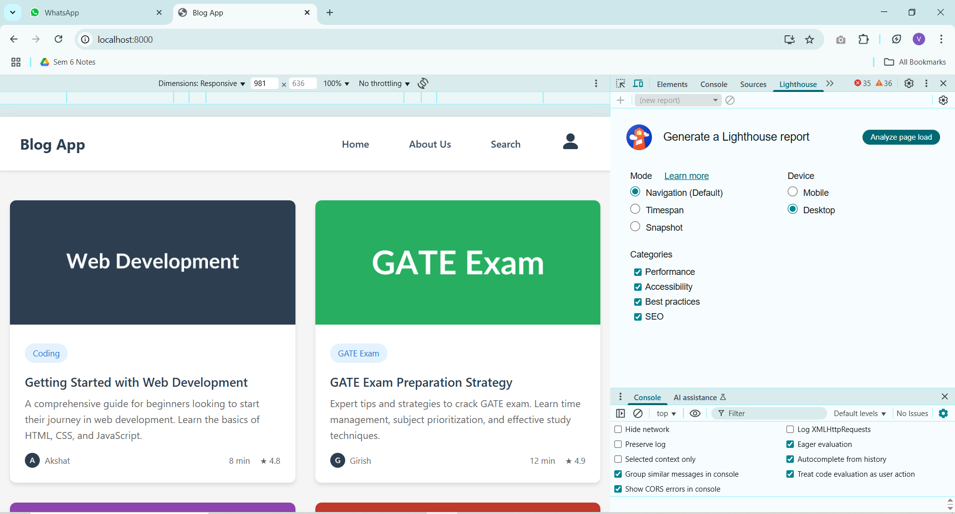

### **4. View the Report**

Lighthouse will run its audit and generate a score report in a few seconds.

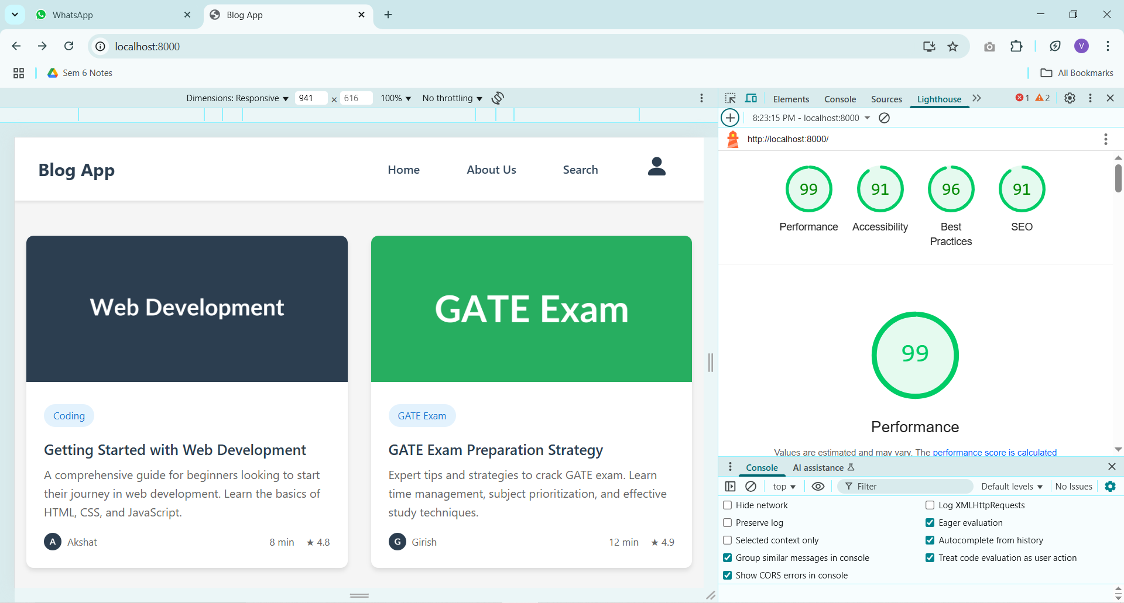

## 

## **Understanding the Scores**

|  |  |
| --- | --- |
| **Metric** | **Description** |
| **Performance** | Measures speed, loading time, and responsiveness |
| **Accessibility** | Checks usability for assistive technologies (screen readers, etc.) |
| **Best Practices** | Analyzes common coding issues, HTTPS, errors |
| **SEO** | Reviews metadata, alt tags, and other ranking factors |
| **PWA** | Tests service workers, offline mode, installability (if PWA is present) |

## **Conclusion**

Lighthouse is an essential tool for modern web developers. It provides a comprehensive report on your website’s strengths and weaknesses, helping you optimize user experience and site performance with actionable insights.

Start using it regularly during development to catch issues early and ship high-quality web apps